# Homework 6

## Flip Flop

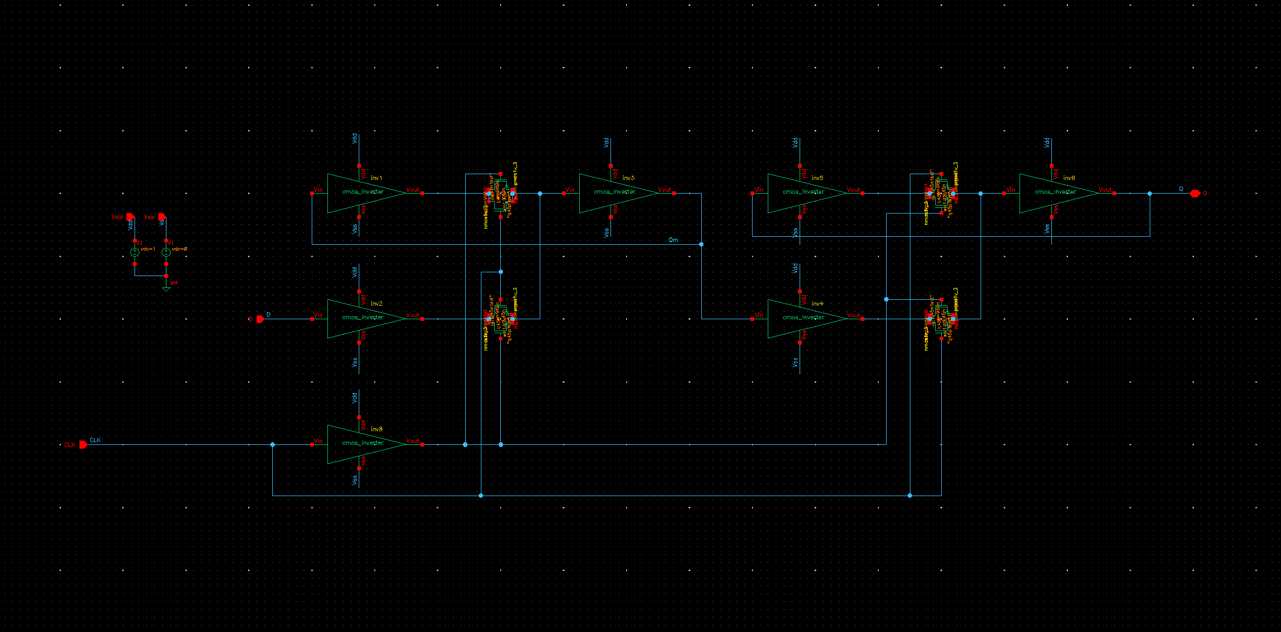

1.92um PMOS, 0.96um NMOS

## Flip Flop Test Bench

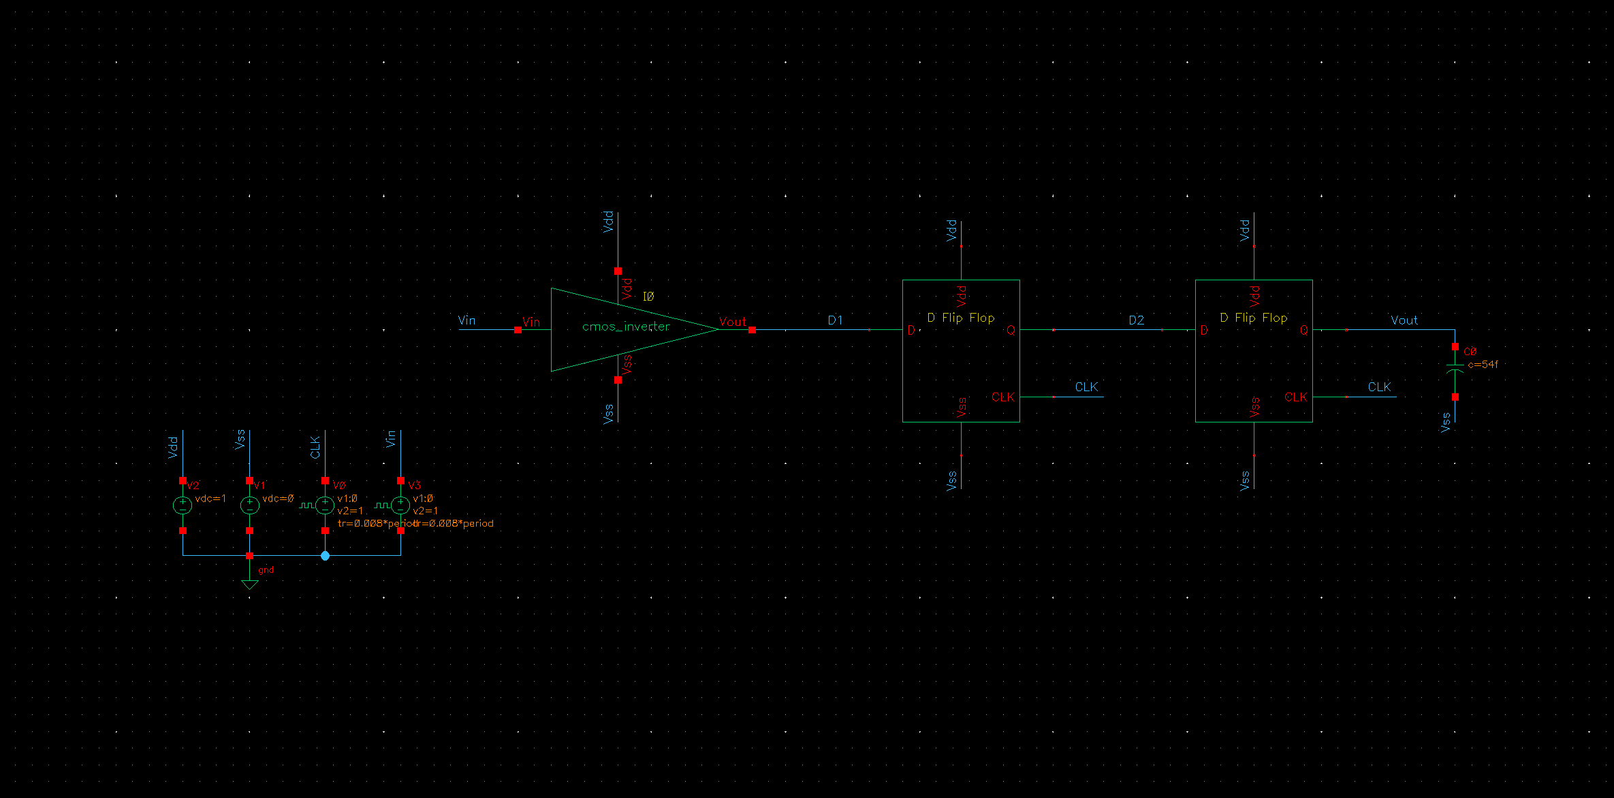

54fF Capacitor on Vout

Setup Time & Hold Time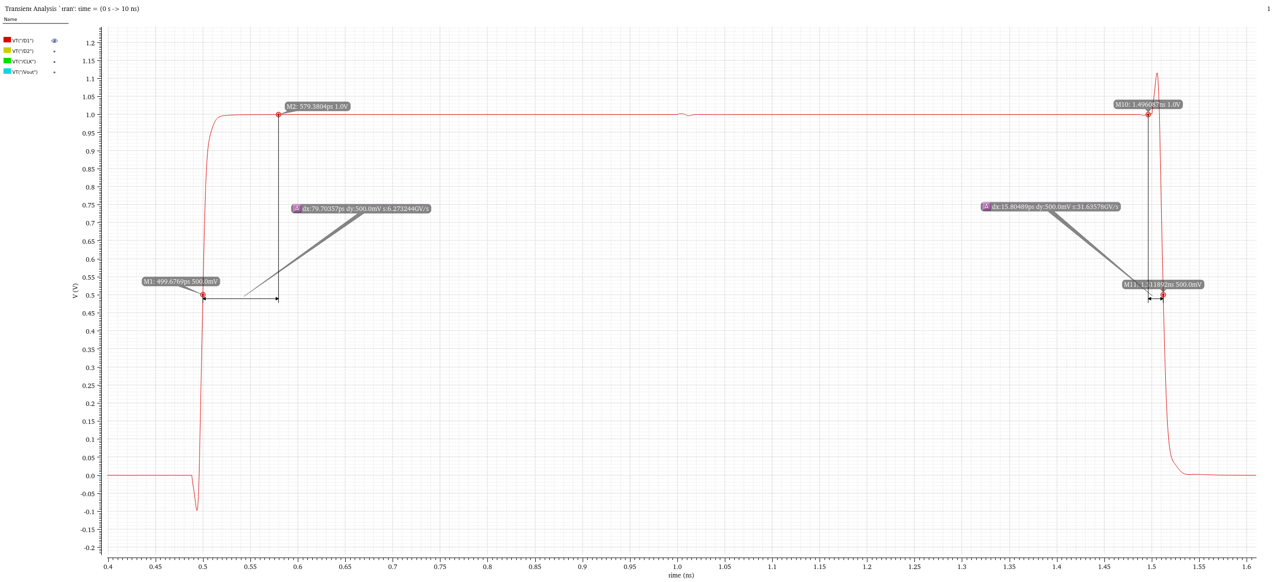

$$t_{su}=79.7ps, t_{h}=15.8ps$$

## CLK to Q time (Falling and Rising Q)

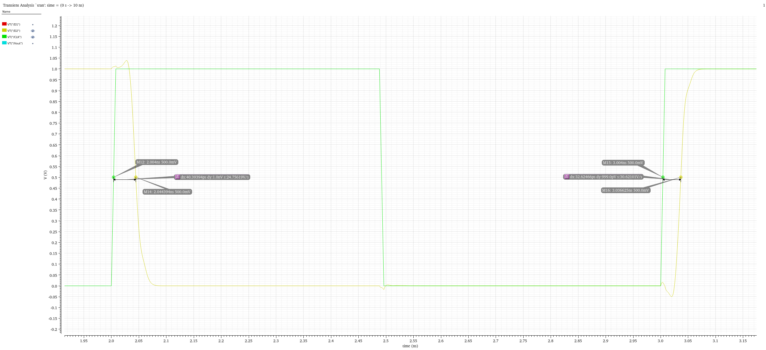

$$t_{cqf}=40.4ps, t_{cqr}=32.6ps$$